**Social Media**

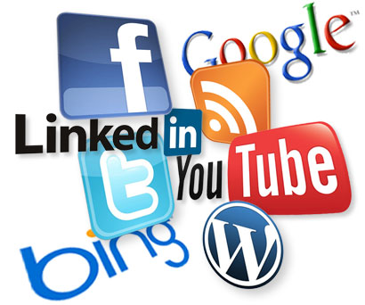

Twitter, Facebook, and Youtube are the top popular names in the amazingly fast and rapidly expanding world of social media and networking. If you want to build up your company’s online reputation and promote your products and services, then you simply cannot shy away from **Quick Web Design social media** marketing.

The reach of a Social Media Marketing campaign is global; you will see instant increases in website traffic, leads, and sales. A recent study revealed that 85% of organizations found that social media efforts have generated exposure for their businesses, while more than half found that social media generated qualified leads.

**Social Media Examples**

* Social media business marketing
* Social media reputation management
* Social media brand management
* Facebook marketing (pages, groups, fans)
* Facebook custom page design
* Twitter marketing strategy
* LinkedIn account management
* Youtube account management
* Blog marketing